Take-Home Exam (Variant 1)
Juan Daniel Parra: 100006002

SRH Hochschule
Software Development and Applications
Dr.-Ing. Grigory Devadze
August 14th, 2026
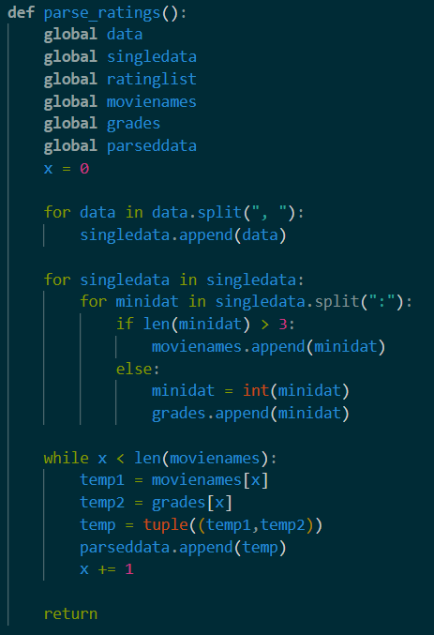
Question 1 – Movie Ratings
To start the process of the Movie Ratings, we take the loaded data (data), and we split it into the individual movie:grade formats into the new list single data. Then, this data is cycled to divide the system into the movie names (movienames) and the grades (grades). Then both lists are joined into a tuple, who is then added into a list of movie names and grades named parseddata. Printing this parseddata gives us the list with the tuples.

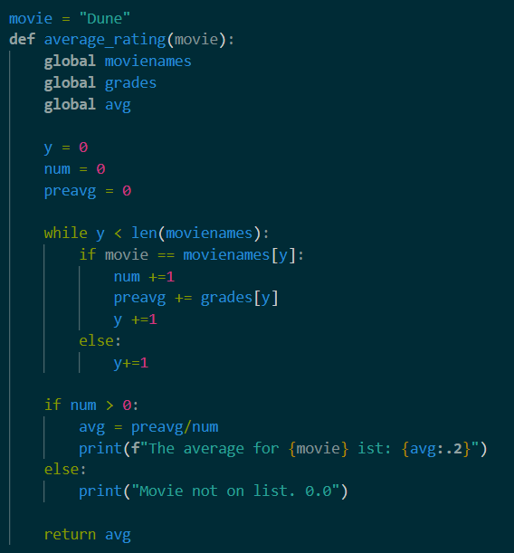
For the average ratings, we take the movienames and grades data, and we use the input (default input: “Dune”) to check what movie are we looking for and add its grade to the value preavg, utilizing the listing cycle. During this process, we also create a variable num to count how many movies there are. Afterwards, we just divide the preavg and the num values to obtain the average. If the movie is not in the list, the num factor is zero, and thus the if function sends a “Movie not on list. 0.0” result.

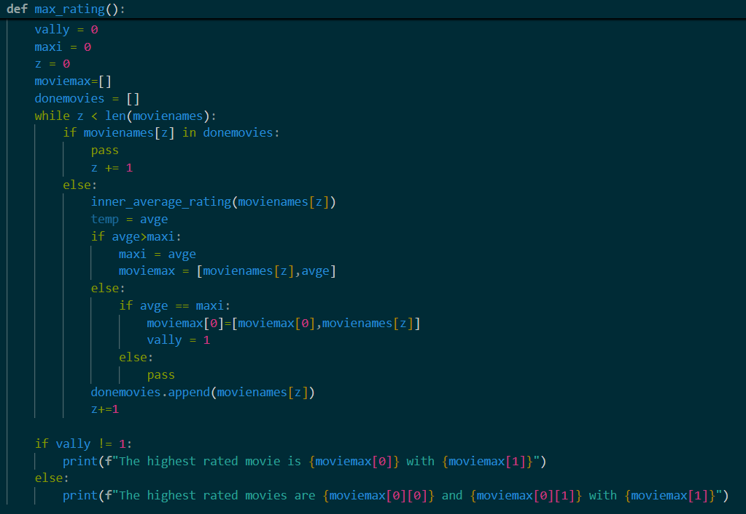
For the max rating function, we use a second average function (that doesn’t return a text) to calculate the average of the movie. Afterwards, we create a list of the movies and its averages by checking it against a list of movies already on the list. This value avge is compared to a value set as maxi and if its higher to the current value, it’s appended to moviemax along with the movie name. In case we have two movies with the same grades, it adds the value vally so the final if defines whether its one or two movies.
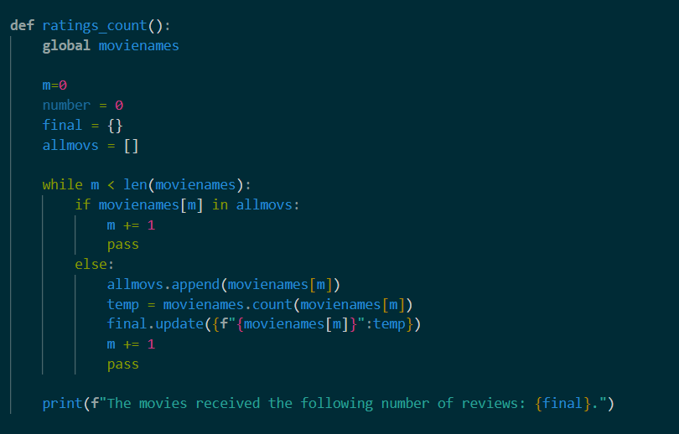
Finally, for the rating counts, we use the same check to see if the movie is already on the list. If it’s not, the movie is counted with the .count function and its result and the movie name is added to a list as a tuple. Then the whole list is printed by itself.

Question 2 - Gradebook

